
Model Switch Map
Instructions
v0.1

Table of Contents
Making switch maps for your models 1
Procedure 1
Preparation 1
Move controls you want to label to the ‘Active layer’ 1
Add your text labels 2
Export your switch map as a .png filename 3
Install the switch map on your radio 5
Appendix 7
Template file 7
Example from template 7
Ng2 glider example (.svg) 7
Ng2 glider example (.png) 7
Sbach342 example (.svg) 7
Sbach342 example (.png) 7

Making switch maps for your models
I have developed a template to allow me to easily create a switch / pots/ trims map for each of my models. I use a full screen Bitmap widget to display the map when I load a model to remind me of my switch, pot and trims allocations for each model.

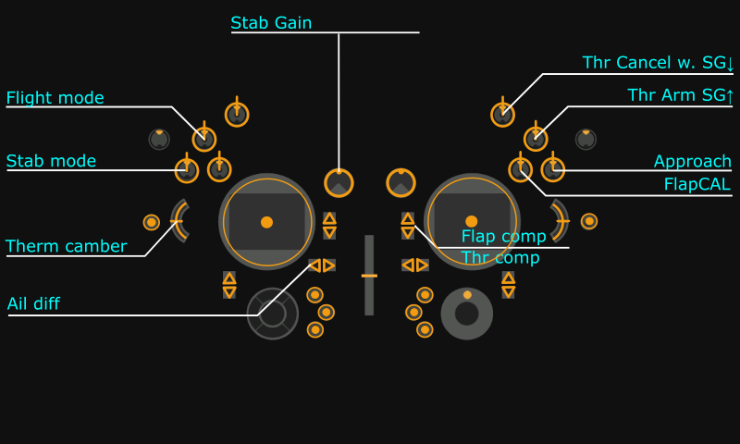

Above is an example I created for my Ng2 glider.

Using the attached template, you can create your own switch maps. I have attached examples for my Ng2 glider and Sbach342 foamy into this Libreoffice file. (If you are reading the PDF version, you will need to get the files from my post on rcgroups in the X20 thread.

The template can be edited in Inkscape, which is a free graphics editor.

Procedure
There are 4 layers in the template: Unused, Active, Controls and background. Initially all 4 layers are visible. Some of the layers will be made not visible before the model file is exported.

Preparation
1. Install Inkscape.

2. Copy the template and examples from the appendix (or from my post on rcgroups) to your working folder.

3. Consider watching an introductory tutorial on Inkscape.

Move controls you want to label to the ‘Active layer’
1. Load the template in Inkscape.

2. Save the template as a new file under a new name so that you don’t alter the template file.

Image file naming rules:
Rule 1: use only the following characters: A-Z, a-z, 0-9, ()!-_@#;[]+= and Space
Rule 2: the name must not contain more than 11 characters, plus 4 for the
extension. If the name is longer than 11 characters, it is displayed in the File
Manager but does not appear in the model image selection interface.

3. Ensure that the Selector Tool is active (click on the arrow pointer icon in the toolbar on the left). For each control that you want to label, select the text and corresponding pointer line while holding down the shift key. Then right click on the selection and select the ‘Move to layer…’ option, then select the ‘Active’ layer as the destination in the drop-down box, see above.

4. Repeat for all controls to be labelled.

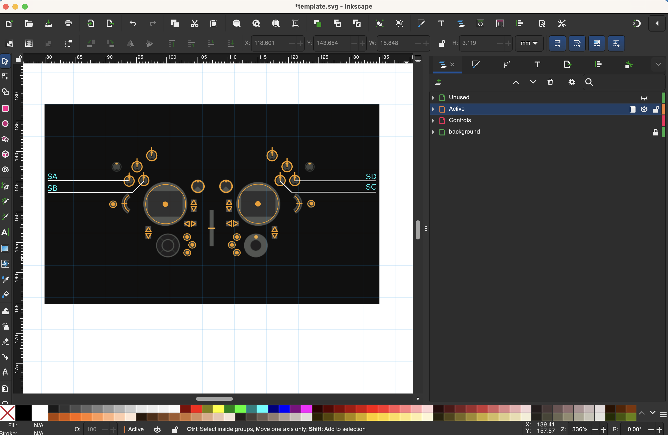

5. Make the ‘Unused’ layer not visible, by clicking on the ‘eye open/eye shut’ icon in layer properties. Only the controls you want to label should now be visible. [Open layer properties by selecting Layer / Layers and Objects in the menu. Colllapse expanded layers in the layer properties so only the layer names are shown, see example above.]

Add your text labels
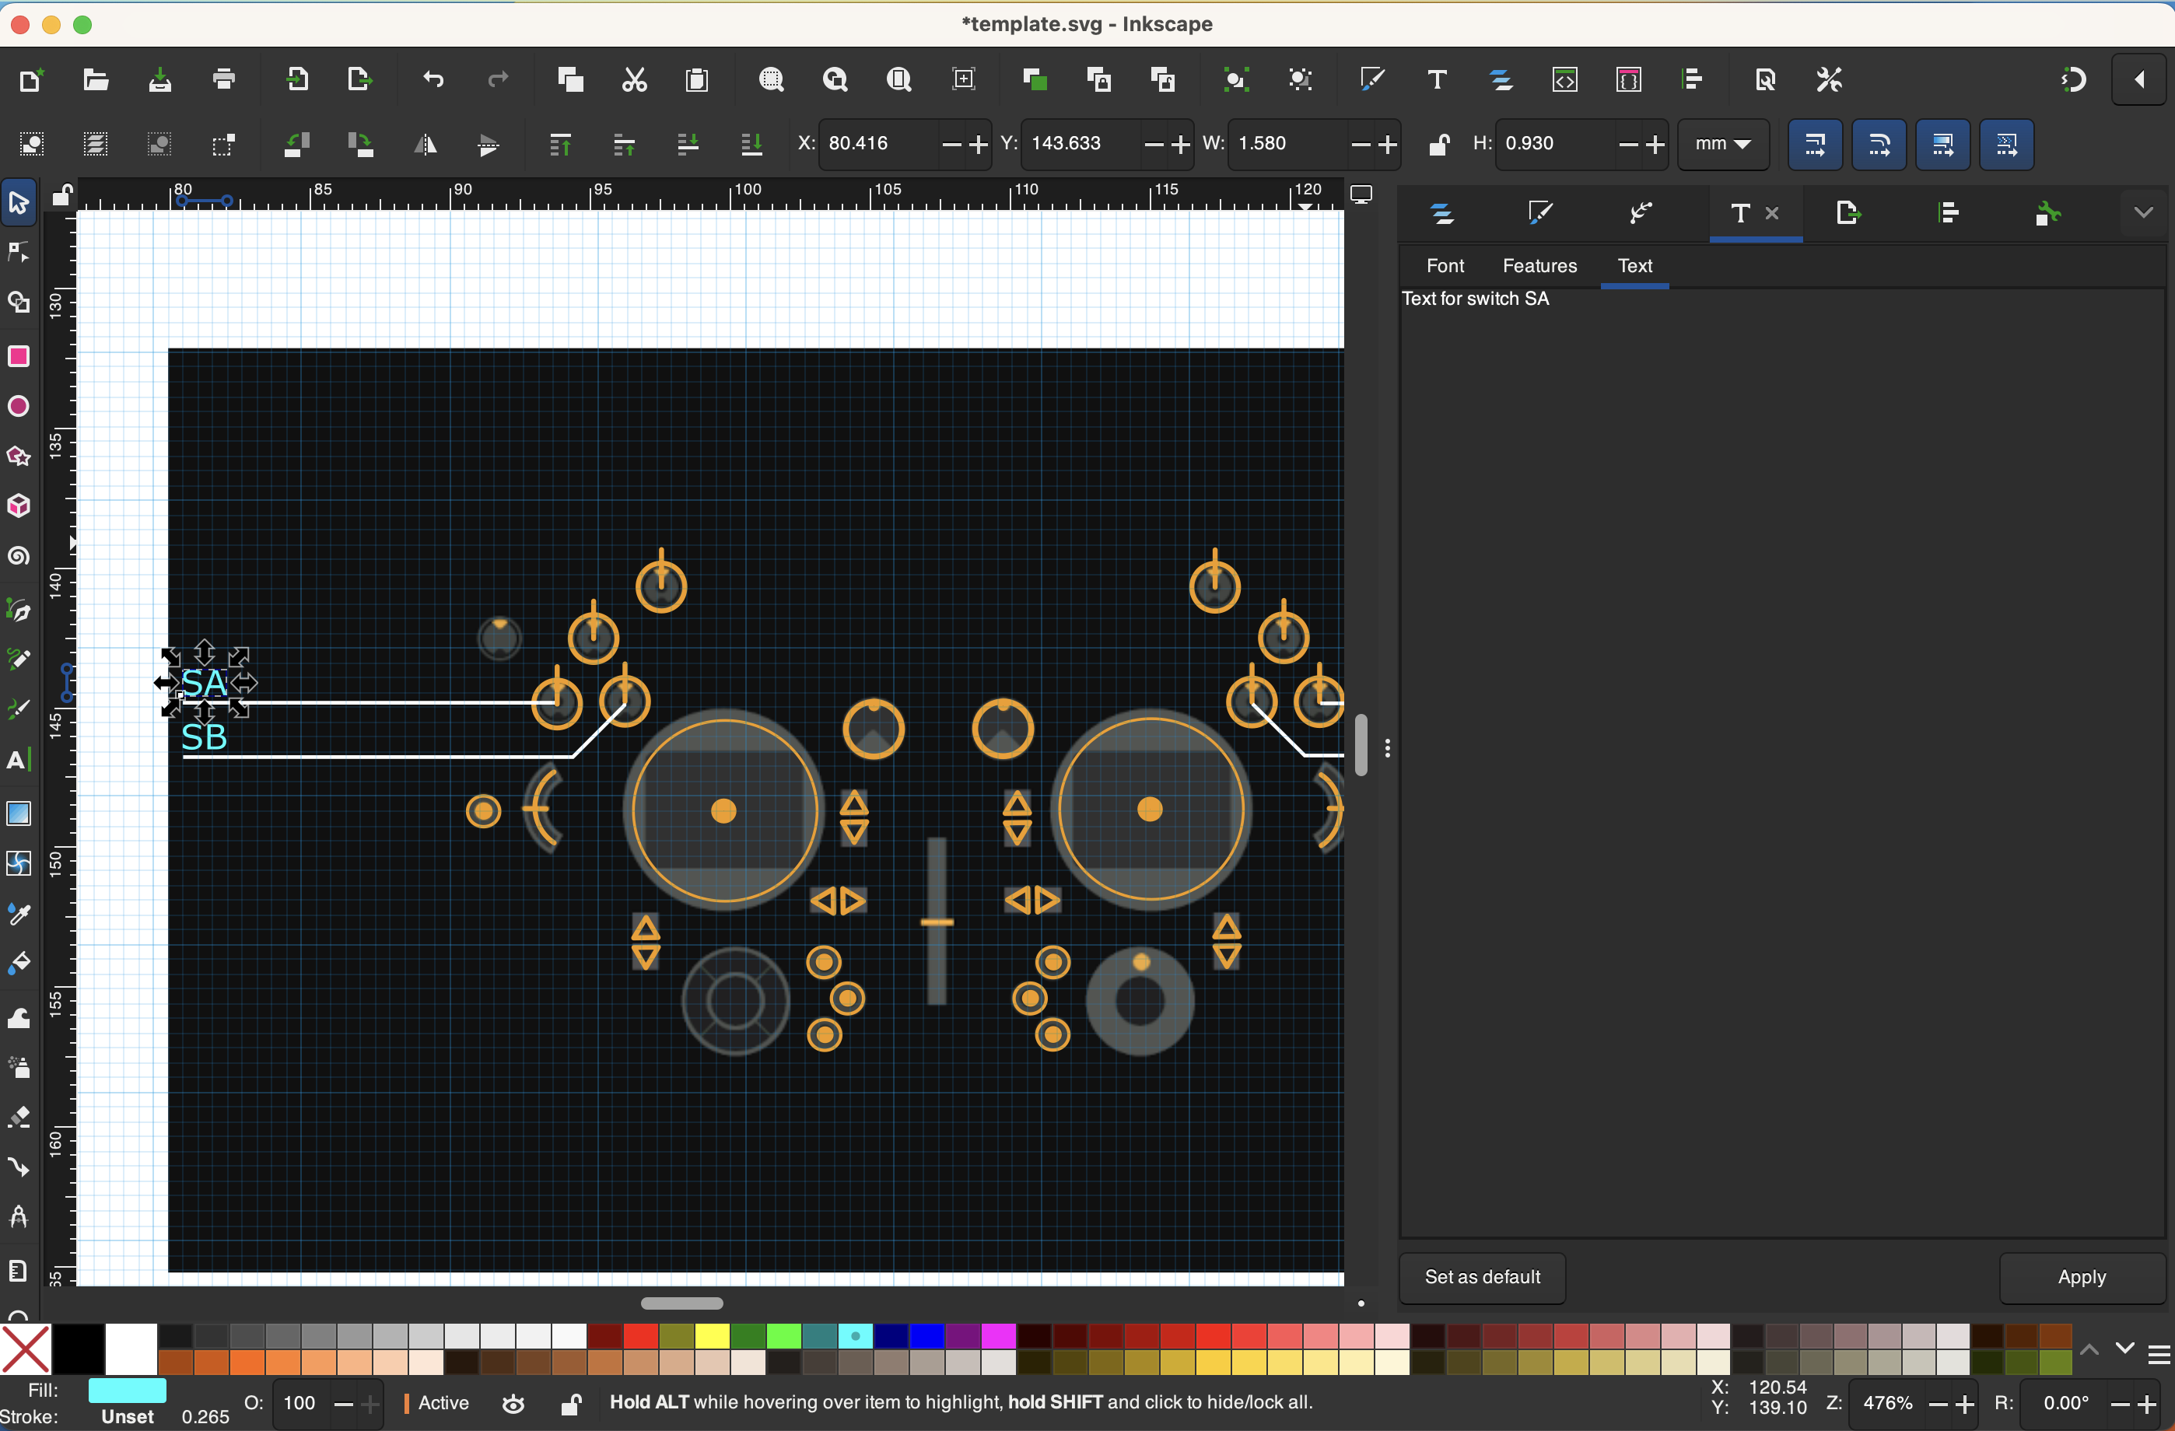

1. Click on a switch/pot/slider text you want to edit, such as switch SA above. In text properties, change the default text (such as ‘SA’ at switch SA) to your desired text. Click on Apply to make the change. [Open text properties by selecting Text / Text and Font in the menu, then select the Text tab in the text properties, see on the right above.]
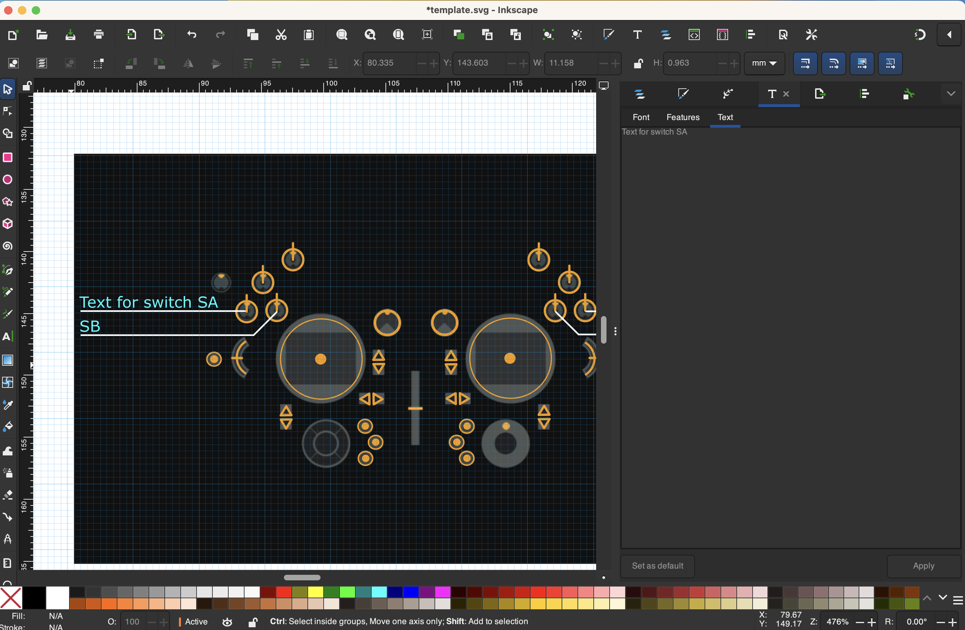

2. The example text is now in place.

3. Repeat for all the desired labels.

Export your switch map as a .png filename
1. Please note that the black background layer is only used so that you can see what the switch map will look like while you are editing. We do not export the background layer, because it would make the bitmap file very large and consume radio resources. In other words we only export a transparent image containing lines and text, and circles for the controls.

2. Click on the Layer properties icon in the propwerties window on the right.

3. Collapse all layers so you only see the layer names Unused, Active, Controls and background.

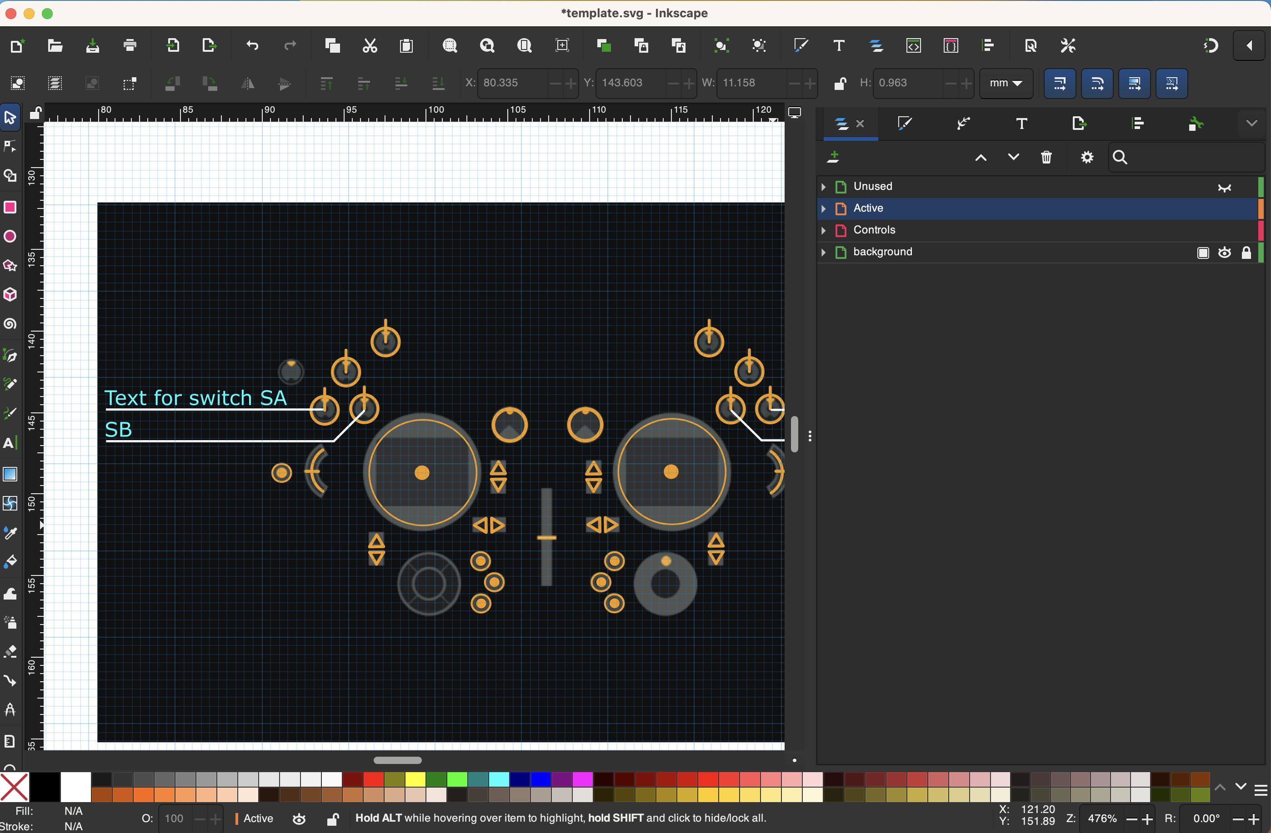

4. The Unused layer was already made not visible above. Now make the background layer not visible, by clicking on the ‘eye open/eye shut’ icon for the background layer in layer properties, see above.

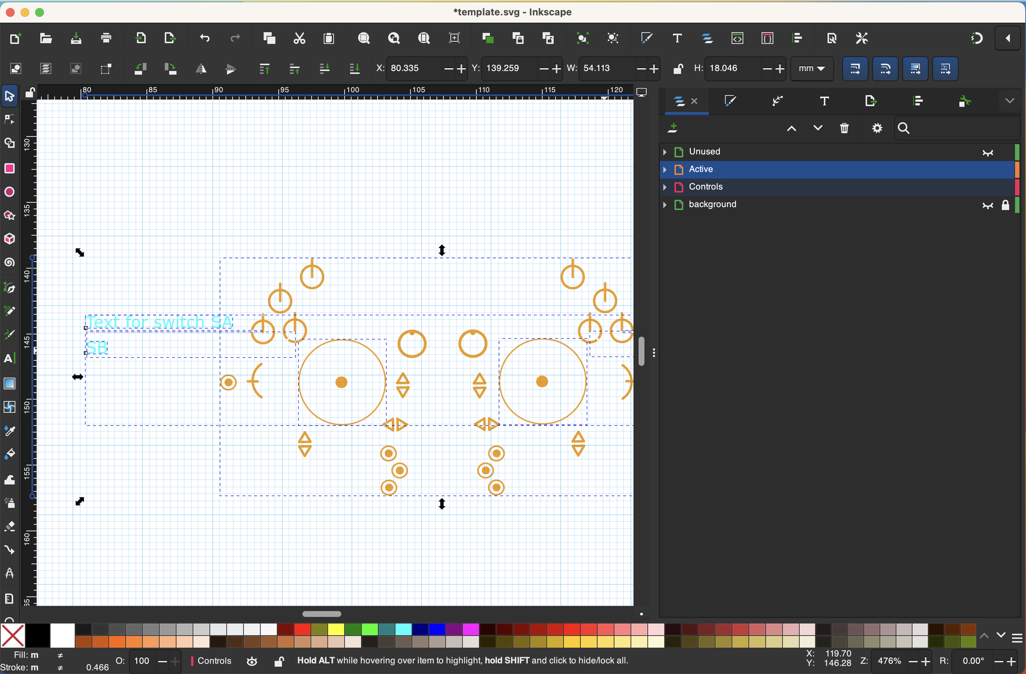

5. The Unused and background layers are no longer visible.

6. Important step: Select the Active and Controls layer by shift-clicking on them in layer properties. The first layer clicked will be dimly highlighted, the second one brightly.

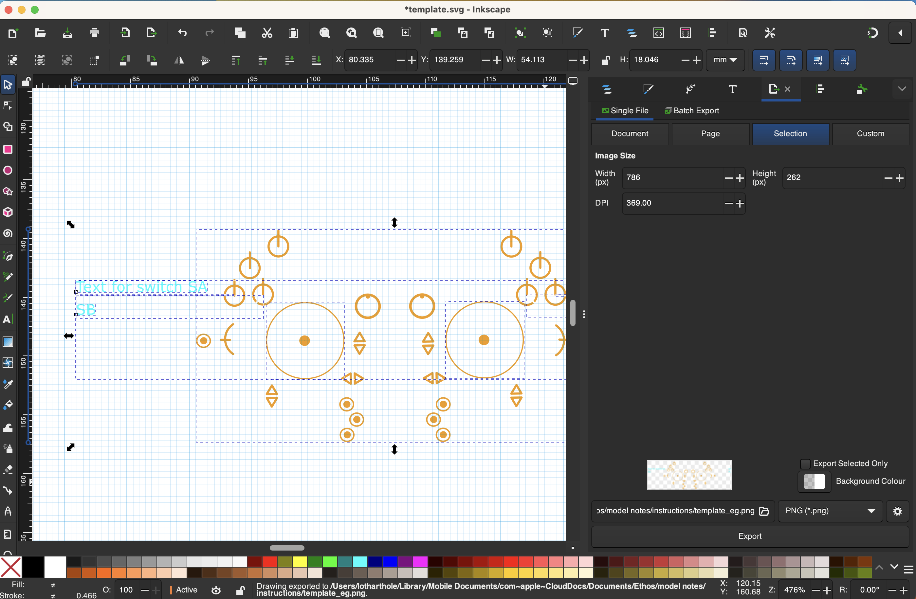

7. Click on File / Export in the menu. Check that you are exporting the Selection, that the exported image width is 786 pixels. Click on the browse button at the bottom to browse to the destination folder and add a file name, then click on Export below it.

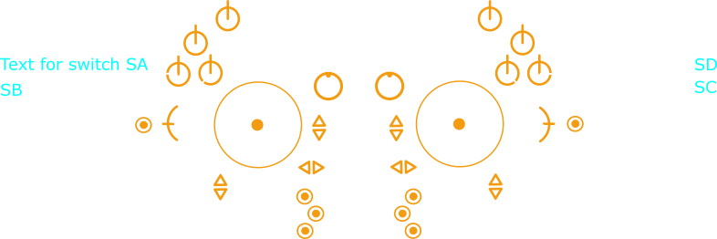

8. Open your exported file to check it, and confirm that there is no black background. This will be added by the radio.

Install the switch map on your radio
1. Copy your switch map file to your radio in the /bitmaps/user folder on the sd card or eMMC.

2. Go to the Configure Screens section and create a new screen using the Full Screen option. See page 319 in the Ethos User Manual v1.6.1.

3. Click on Configure, and select the Bitmap widget. See page 311 in the Ethos User Manual v1.6.1.
- Bitmap type: User bitmap
- Bitmap file: <<your switch map.png>>

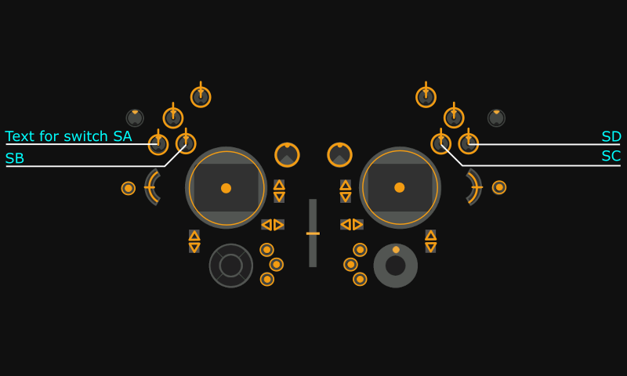

4. Power up the radio, and press the Page Up/Down to get to the newly added screen. It should look similar to the above.

Appendix

Template file

Example from template

Ng2 glider example (.svg)

Ng2 glider example (.png)

Sbach342 example (.svg)

Sbach342 example (.png)

